Sweet Delights Picnics Breakfast Grazing Menu
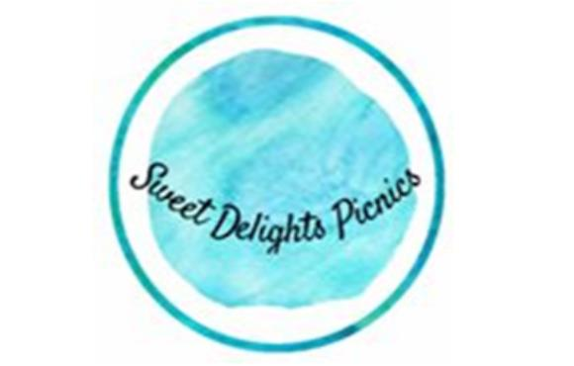

- Croissants (variety of ham/cheese, cheese tomato, chicken avo, cheese and plain)
- Waffles
- Pancakes
- Choc Hazelnut Crepes
- Variety of fresh seasonal fruits
- Vienna Loaf w, Condiments e.g. honey, butter, vegemite, Nutella etc
- Smashed Avo
- Yoghurt and Muesli Bowls
- Variety of Sweets
- Pastries

Extras (not included in set price)
- Individual Kombucha Bottles $7 each
- Caramilk Waffles x10 $27
- Choc Coated Strawberries $1.5 each (ONLY AVAIBLE WHEN IN SEASON)
- Sugar Cookies $4 each

